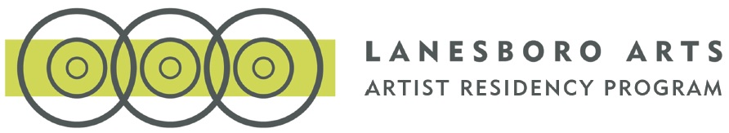
Lanesboro Early Career Artist Residency Application: Round Two
*This document is for preview and/or preparation only. Final application must be entered into the online application form, made accessible after round one, to be considered.
Cover Sheet
Name
First:
Last:
Email:
Project Information
- Describe the Studio/Workspace needed to complete your Residency Project*

- How Does This Project Benefit from Happening in Lanesboro?*
  - Please provide a brief 4 – 5 sentence description addressing how Lanesboro and its unique rural context would benefit your proposed Place-Based Residency Project. Some items to consider:
    - How is your project enhanced or made different by doing it in Lanesboro?
    - What is the most essential aspect to staging or undertaking this place-based artistic project in Lanesboro?
    - How would Lanesboro and it community inform this project (and vice versa)?

Residency Dates
Lanesboro Arts Residencies can be scheduled in January, February, March, April, May, July, August, or September. Residencies scheduled in April or August are generally preferred and would be most optimal, however Lanesboro Arts staff is interested in considering proposals with flexible and dynamic artsits throughout the year. Residencies generally begin around the 1st or 16th of each month and end on the 15th or last day of each month for periods of 2 or 4 weeks. Dates can be split into two visits only if that best suits your practice and project. If selected for a residency, Lanesboro Arts staff will work with you to determine the exact dates best for all parties.
- First Choice*:
- Second Choice*:
- Third Choice*:
Proposed Residency Project Description
- Upload Your Place-Based Project Description*
Lanesboro Arts strives to provide artists with a dynamic and compelling array of community assets while seeking out projects where the activation of the people and places of Lanesboro are at the core of the artistic process.
  - Maximum 750 Words.
  - Describe in more length and detail your proposed Residency Project along with addressing these questions:
    - How can your project help achieve change in Lanesboro?
    - How can it address or create an opportunity to move the community forward or otherwise be central to problem-solving?
  - Be as specific as you can about your vision for engaging the community in the process of your project.

Supplemental Application Information

References
Please provide two references.
Reference #1*
- First Name:
- Last Name:
- Affiliation / Title:
- Daytime Phone:
Reference #2*
- First Name:
- Last Name:
- Affiliation / Title:
- Daytime Phone:

List of Work Samples

Work Samples should be from within the past two years, and directly related to your proposed Residency Project. Work samples will be submitted via Dropbox or Google Drive in the following format: Work samples should be from within the past two years, and directly related to your proposed Residency Project. Work samples will be submitted via Dropbox or Google Drive in the following format: Visual Art/Mixed Media: 6-8 images (jpg, tiff, png, pdf, gif) Performance/Mixed Media: 3-5 video clips, each no more than 3 minutes in length (mpeg4, mov, avi, mkv, wmv, or links on Vimeo or YouTube) Music: 3-5 audio and/or video clips, each no more than 4 minutes in length (mp3) Writing: 6-10 pages of prose/poetry/fiction/non-fiction/playwriting
Work Samples *
Add up to 8 works by clicking the plus (+) button to add a new row
- Title of Work
- Medium/Genre
- Date of Completion (or Work-in-Progress)
Dropbox or Google Drive URL*
Share your work samples via a folder in Dropbox or Google Drive by providing the URL here. IMPORTANT: If submitting work samples via Google Drive, please ensure the folder is shared publicly. Here is an example of what a link to a folder in Google Drive looks like: https://drive.google.com/drive/u/0/folders/0B5g-CKN-b2d9SW4eUnV1dTr3Z0U
PLEASE double check that you are sharing a link to a public folder visible to anyone with the link and that your link points to an entire folder and not just one file. These are the two most common application errors. Please contact Lanesboro Arts or conduct research online if you need assistance in creating a public folder of your work samples.

List of Work Samples
- Upload your Resume*
  - Accepted file types: pdf, doc, docx, Maximum file size: 300 MB.

