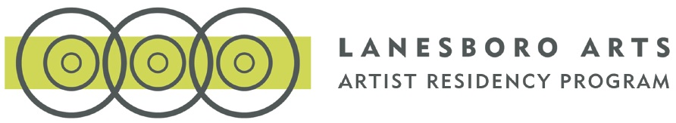
Lanesboro Early Career Artist Residency Application: Round One
*This document is for preview and/or preparation only. Final application must be entered into the online application form found here on Lanesboro Arts’ website to be considered.
Cover Sheet
Name
First:
Last:
State of residence*
You must be a resident of MN or NY (NYC only) to apply.
- Minnesota
- New York (New York City only)
Address
Street Address:
Address Line 2:
City:
Zip Code:
Contact
Phone number:
Email:
Website:
Artist & Project Information
- Acknowledgement*
Please check the box below to acknowledge you understand this residency program's place-based focus.
  - I understand this program's place-based focus, my practice is informed by place and community, and I am interested in utilizing my art and/or artistic process to activate the people & places of Lanesboro while instigating positive change.
- Artistic Discipline(s)*
  - Ceramics
  - Design
  - Drawing
  - Fiber / Textiles
  - Glass
  - Landscape Archictecture
  - Metal
  - Mixed Media
  - Electronic Arts
  - Media Arts
  - Music
  - Painting
  - Performance (specify below)
  - Photography
  - Printmaking
  - Sculpture
  - Wood
  - Interdisciplinary
  - Writing (specify below)
  - Other (specify below)
Please check all that apply.
- Introductory Description of Your Proposed Place-Based Residency Project*
  - Please provide a brief 3 or 4 sentence introductory description of your proposed Place-Based Residency Project

Artist Statement
- Please Provide a Brief Artist Statement About Current Work*
- 2500 max characters
Early Career Artist Status
Only early career artists are eligible to participate in the Lanesboro Artist Residency Program. For more details, review the program guidelines.
- Project Timing & Impact as Early Career Artist*
In 1500 characters or less, please address how this place-based residency in Lanesboro will further your work and career as an early career artist.
- 1500 max characters

Demographic Information
People who are Black, Indigenous, Native, People of Color, LGBTQIA+, and/or People with disabilities will be prioritized in the selection process.
- Racial / Cultural Origin
  - Native American/American Indian/Native Alaskan
  - Asian
  - Black/African American
  - Hispanic/Latino/Chicano/Latinx
  - Middle Eastern/North African
  - Native Hawaiian/Pacific Islander
  - SWANA (South West Asian and North African)
  - White
  - I prefer to list my racial/cultural origin below
  - If you prefer to list your racial/cultural origin, please do so in the space provided here:
- Gender Identity
  - Male
  - Female
  - Non-Binary
  - Genderqueer
  - Transgender
  - I prefer to list my identity below
  - We understand gender identity is complex, so if you prefer to list your gender identity or expand, please do so in the space provided here:
- Pronouns
  - She/Her
  - He/Him
  - They/Them
  - I prefer to list my pronouns below
  - If you prefer to list your pronouns, please do so in the space provided here:
- How did you hear about this program?
  - Website
  - Social Media
  - Direct Mail
  - Lanesboro Arts email newsletter
  - Referral
  - Publication (please specify)
  - Other (please specify)

